**Mission Statement:**  
At ATZ, our mission is to provide a seamless and innovative online shopping experience by offering high-quality products, exceptional customer service, and secure transactions. We aim to connect buyers with the best products at competitive prices while ensuring convenience, reliability, and satisfaction.

**Vision Statement:**  
Our vision is to become a leading eCommerce platform recognized for its trustworthiness, diverse product range, and customer-centric approach. We strive to leverage cutting-edge technology to enhance the shopping experience, foster long-term relationships with our customers, and contribute to the growth of digital commerce globally.

Ecommerce or "electronic commerce" is the trading of goods and services online. The internet allows individuals and businesses to buy and sell an increasing amount of physical goods, digital goods, and services electronically.  
  
Some businesses sell exclusively online or use ecommerce to expand the reach of their other distribution channels. Either way, ecommerce is thriving and can be a profitable venture. Let’s dive into the details of how ecommerce works and find out if it’s right for you.

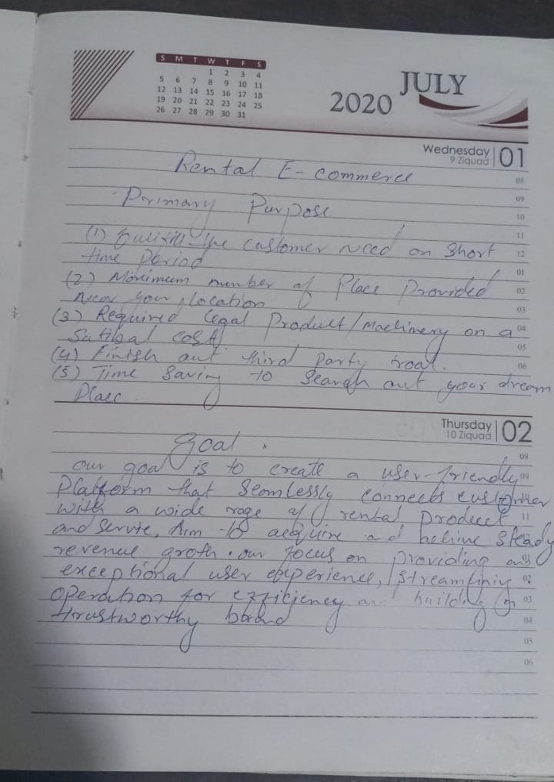

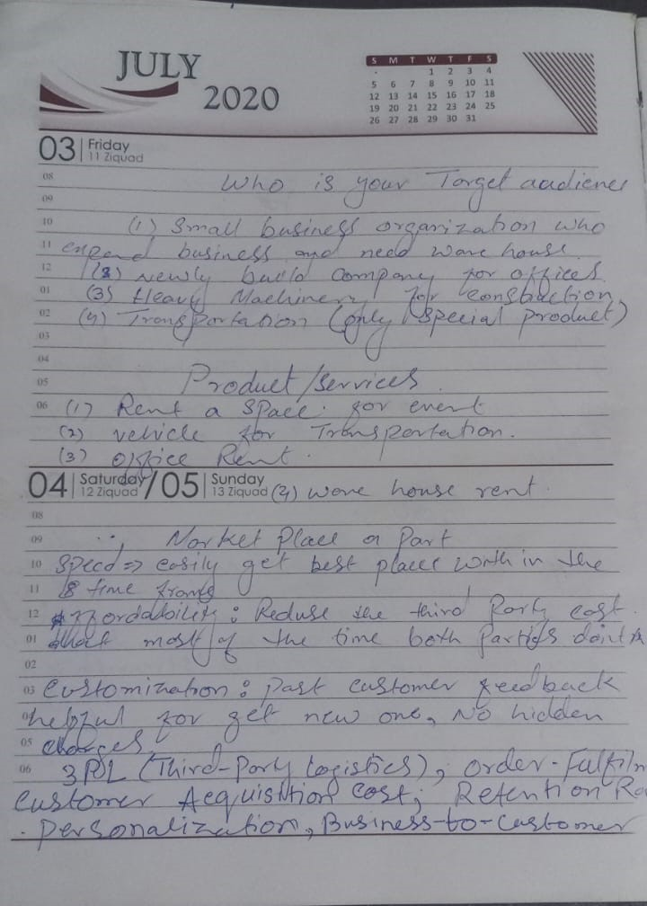

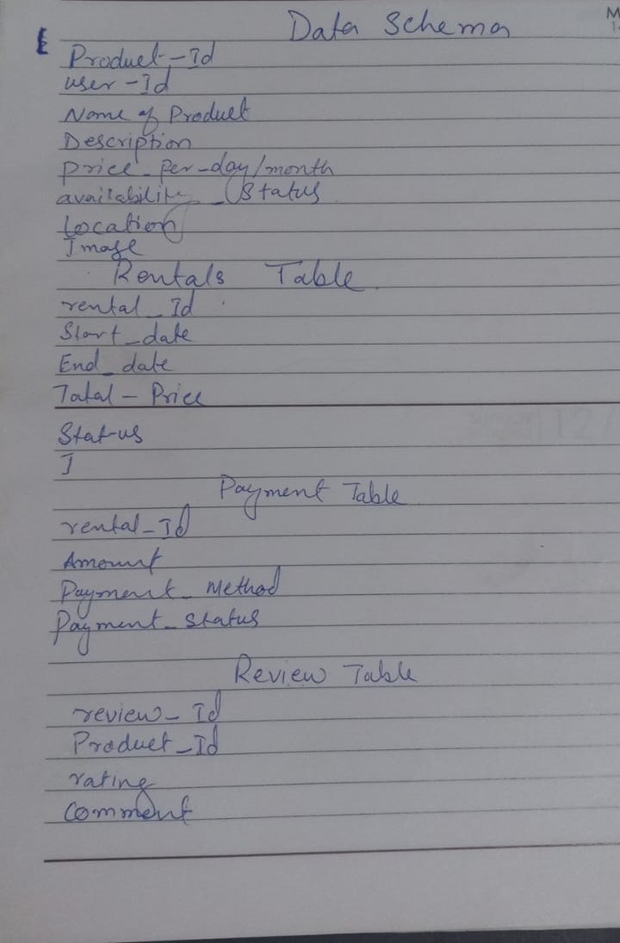

UI/UX template:

Yes, I am update, add, or remove pages as needed.

As per template 4 API data structure is not match with the schema structure.

Sanity Documentation. Successfully install it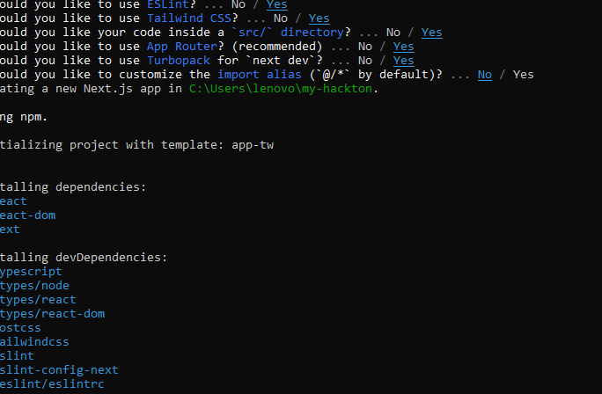

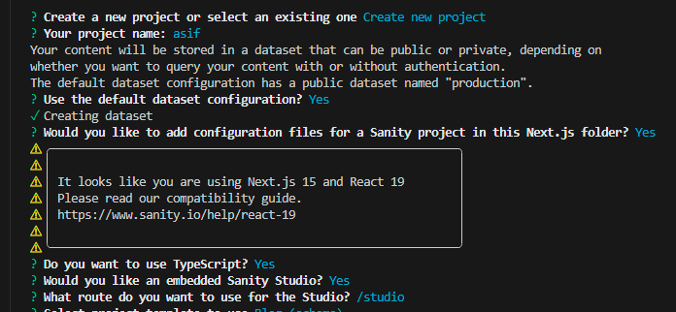

Successfully install my project in sanity.io

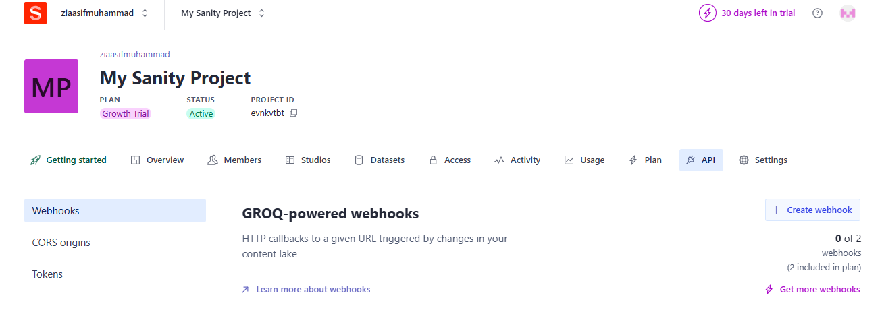

Create a localhost 3000 in CORS origins

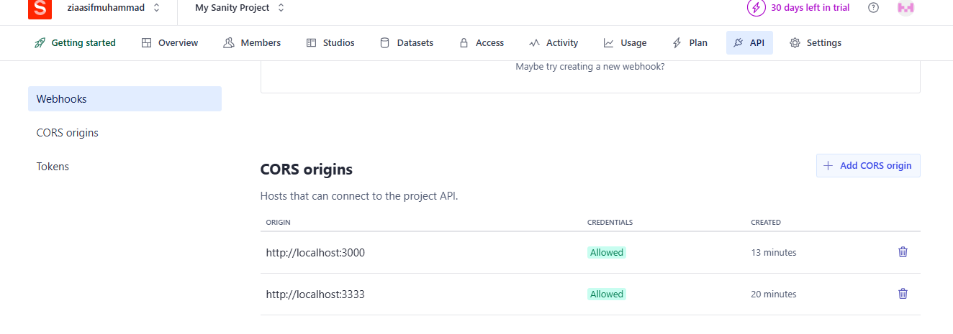

Create a token

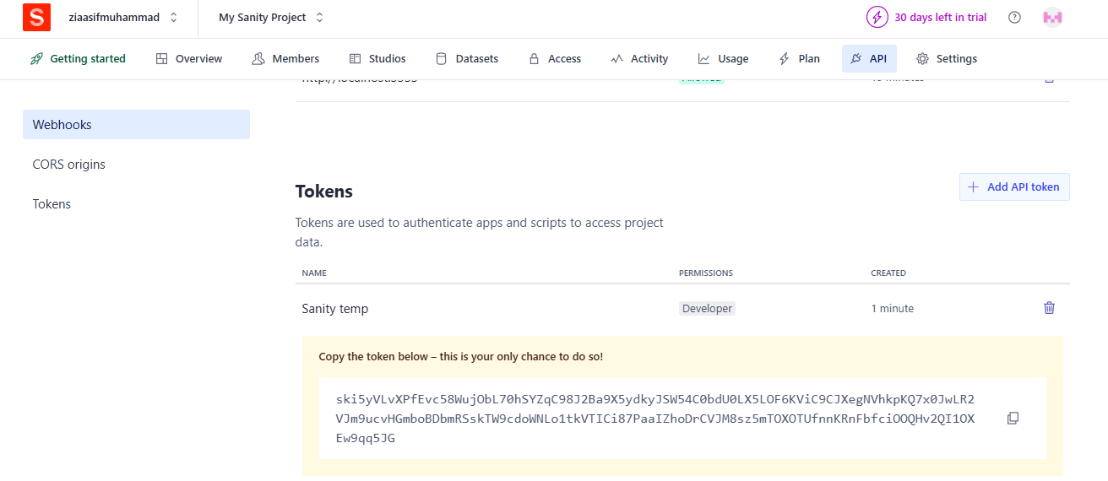

Prepare sanity product structure

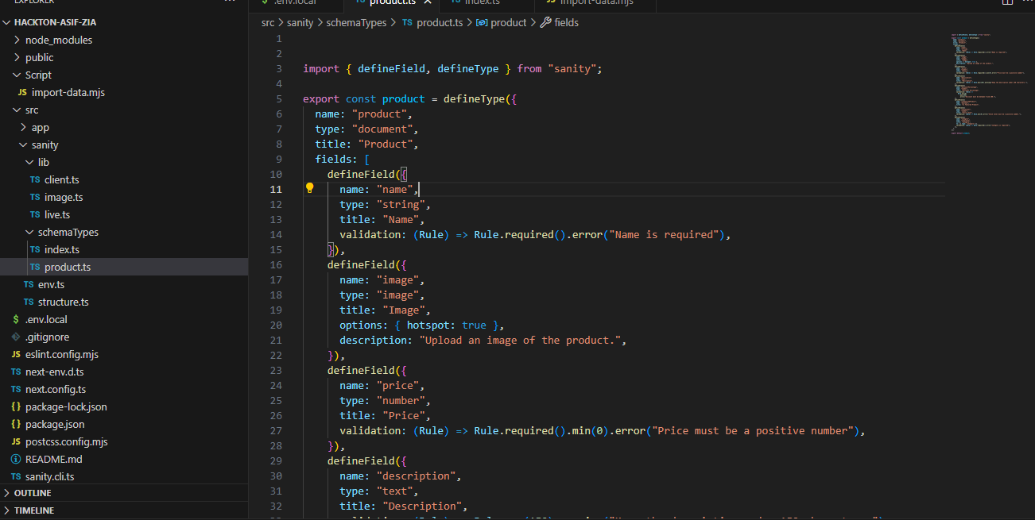

Create category field in it

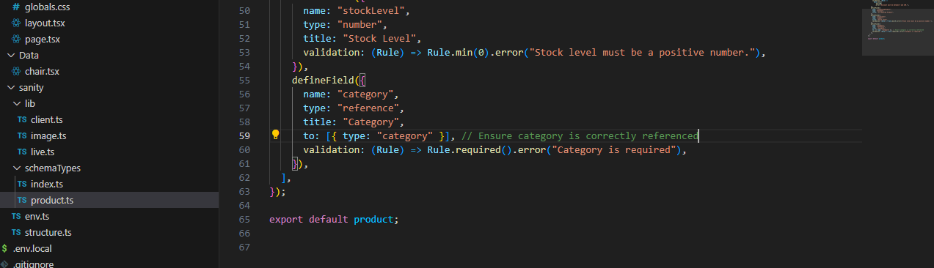

Update package. json file in which data import

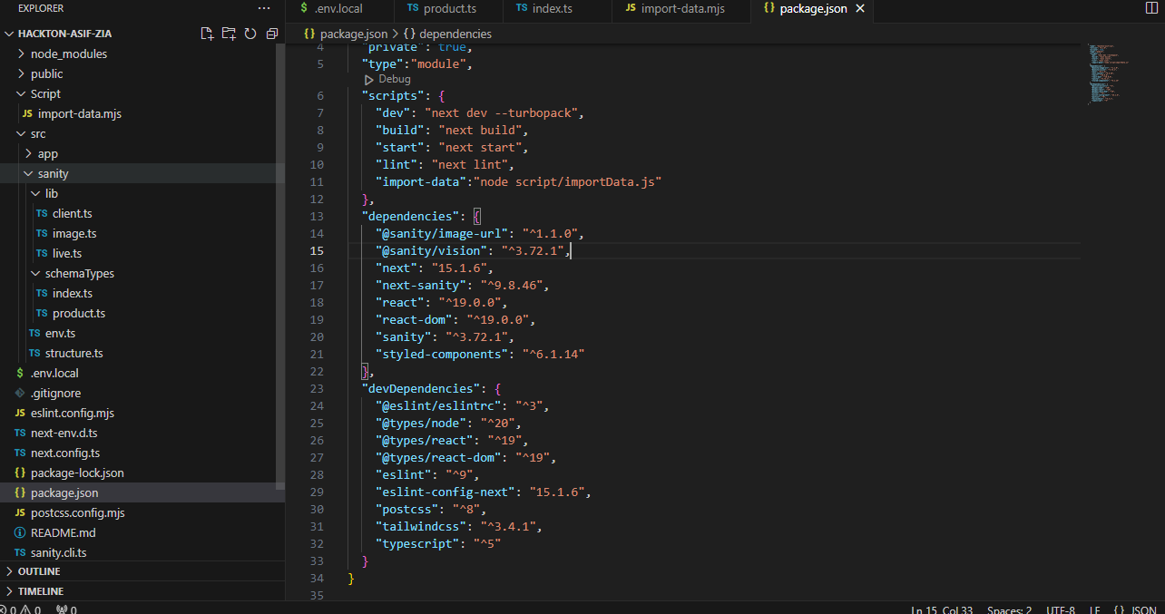

See here I fetch data from sanity using groq query for display frontend.

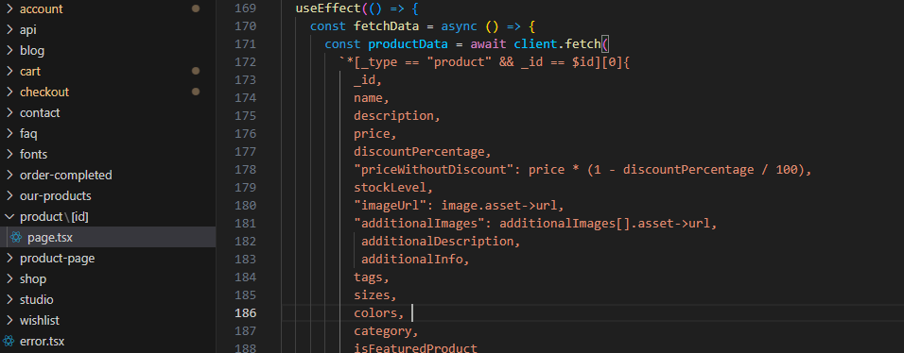

Here is a product detail that is fetch from API

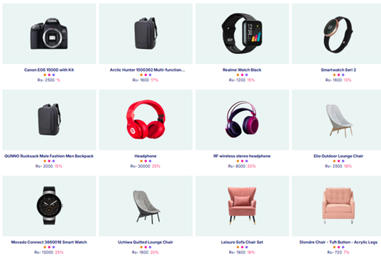

In day 4 I have created multipul component to support our web site like feature product, latest product, client view latest blog and so on page screen short attach.

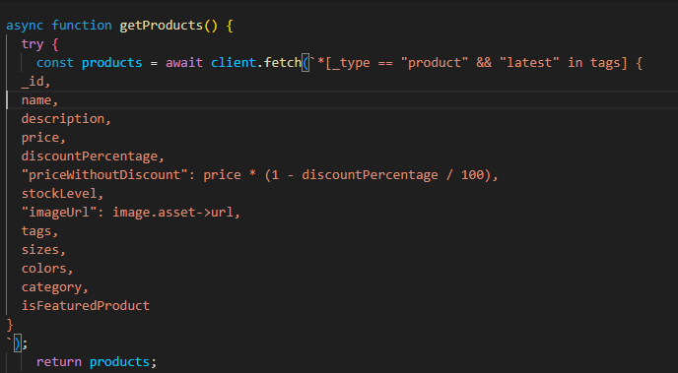

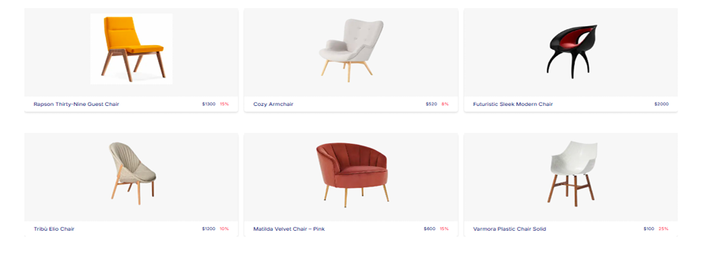

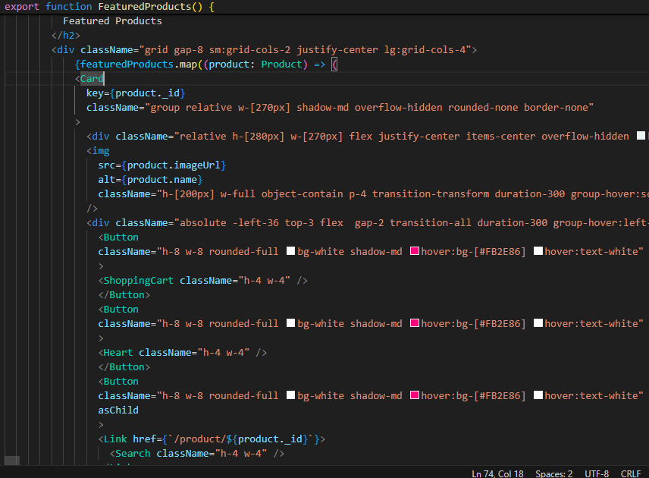

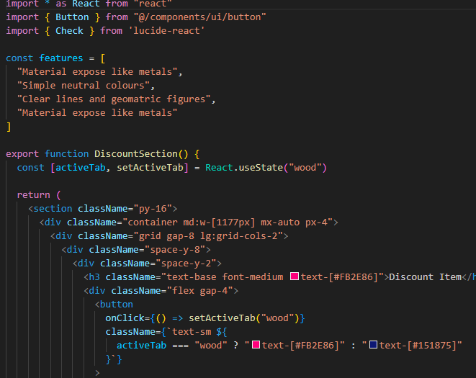

Wishlist code along with picture

